CLEANERS
Required ASAP
Hours : Negotiable
£11.95 per hour
Due to the cleaning contract coming in-house we are now looking for several cleaning staff to join our long serving and experienced team. You will assist the cleaning team to carry out and complete cleaning tasks as set by the school's standards and policies. The role will include all types of cleaning and you will be required to undertake a variety of duties to ensure the essential cleanliness and hygiene of the school. Applicants will need to comply with health and safety rules for safe working and chemical handling. Experience in this field would be beneficial but is not essential as full training will be provided.
Shenfield High School is a standalone 11-18 Academy with a comprehensive ethos and a commitment to high academic standards supported by a significant investment in pastoral care and wellbeing.
The school is conveniently located close to Shenfield mainline station on the line into London Liverpool Street and home to the eastern terminus of the new cross rail Elizabeth Line. The school’s location attracts outer fringe London allowance.
If you would like an informal discussion about this position and/or a pre-application visit please contact the Headteacher’s PA, Mrs Watson: c.watson@shenfield.essex.sch.uk
The Governing Body is committed to safeguarding and promoting the welfare of children and young people and expects all staff to share in this commitment. This appointment is subject to an enhanced disclosure check and positive references.
- Closing date for applications: 19th July 2024
For an application form please visit our website or contact our HR Manager Mrs Whordley k.whordley@shenfield.essex.sch.uk

JOB DESCRIPTION
Job Title | Cleaner
Grade | Scale 1
Reports to | Estate Manager
Responsible for | N/A
Liaison with | Caretaker, Classroom Teachers, support staff and Headteacher.
Job Purpose | To undertake cleaning within the school according to Procedures Codes using a variety of methods including machinery and adhering to safety regulations.
Duties | - To carry out cleaning in all and any areas of the school.  - Frequency of cleaning to be undertaken as directed by Procedure Codes.  - Assisting with the locking and unlocking of school buildings and rooms.  - To carry out as necessary the replacement to roller towels, renewing supply of toilet rolls and replacement of bin liners.  - To assist as necessary with the cleaning up after break-in or vandalism at the school.  - In emergency situations to assist with the clearing of snow and ice from paths and entries.  - To undertake training in the correct use of cleaning equipment such as floor machines, Vacs, wets pick-ups and in health and safety and the use of cleaning chemicals.  - To notify the Caretaker or other Senior member of staff, of any damage to buildings and equipment or of anything you see that may be dangerous to pupils and/or staff.  - All employees are expected to show a responsible attitude to health and safety issues and have due regard for their personal safety and that of others.  Such other duties relating to the cleanliness of the school premises as may be necessary from time to time within the reasonable requirements of the Headteacher and Governing Body.
General | - To participate in the performance and development review process, taking personal responsibility for identification of learning, development and training opportunities in discussion with line manager.  - To comply with individual responsibilities, in accordance with the role, for health & safety in the workplace  - Ensure that all duties and services provided are in accordance with the School’s Equal Opportunities Policy  - The Governing Body is committed to safeguarding and promoting the welfare of children and young people and expects all staff and volunteers to share in this commitment.

ABOUT US
Shenfield High School is a standalone 11-18 Academy with a comprehensive ethos and a commitment to high academic standards supported by a significant investment in pastoral care and wellbeing.
We have over 1500 students on roll including more than 300 students in our sixth form; this year we have received over one thousand applications for 240 places in year 7 in September 2023.
We offer a broad and rich curriculum from years 7 to 13 with a full commitment to the traditional academic, creative and the physical. Our reputation for sport, both elite and recreational and for our creative arts is second to none for a state comprehensive school. Through the efforts of our highly engaged staff the curriculum runs strongly through into the extracurricular with clubs and activities offered in all areas.

The whole school community has devoted significant time in the past two years revisiting the school values and the House System.

Our school values form the basis of our behaviour and rewards policies and underpin our school culture whilst our House System forms the scaffold for our student leadership structure.

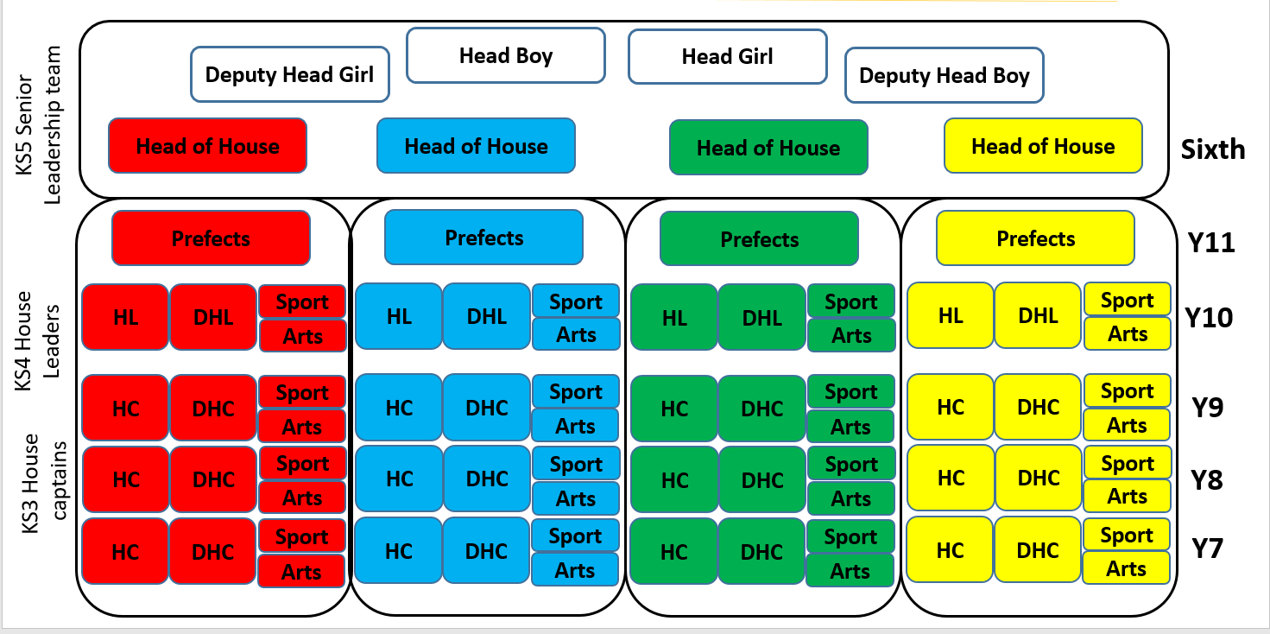

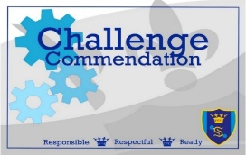
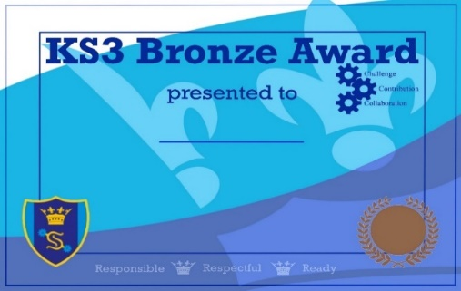
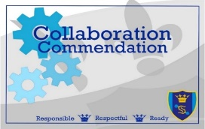

Student Leadership is no more evident than in our very own Combined Cadet Force (CCF). Our contingent is affiliated with the Royal Anglian Regiment and is the largest school contingent in the country outside of fee paying schools.

Our greatest asset is our staff, ‘Team Shenners’. The majority of our teaching staff are very experienced and committed to Shenfield High School and they are complimented by a group of newer entrants to the profession who bring fresh ideas and energy to the school. The teaching team works hand in hand with the highly qualified and experienced support staff who are integral to the daily functioning of the school.
The new Deputy Headteacher for Behaviour and inclusion will work most closely with our large pastoral and safeguarding teams together with our SEND team who are very ably led by the school’s SENCo. The school’s investment in student wellbeing speaks to our inclusive ethos.
Shenfield High School is a strong community of staff, students, and their parents. Parents are very supportive of the school and recognise the uniqueness of some of the opportunities their children are afforded by attending the school.
As a standalone academy it is our governing body that works in partnership with the Headteacher and senior team in setting the strategic direction of the school. Our governors come from a variety of backgrounds and professions and are very supportive of the school.

